1. Login registration using invalid data :

I interacted with the Login page and noticed the following :

- Request: POST( information has been sent to the server), status code 200 (action was successfully received)

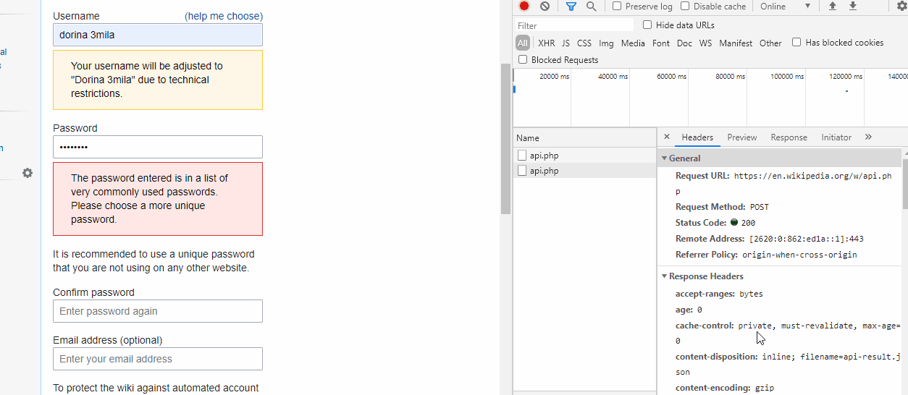

- Server response (Please choose a more unique password)

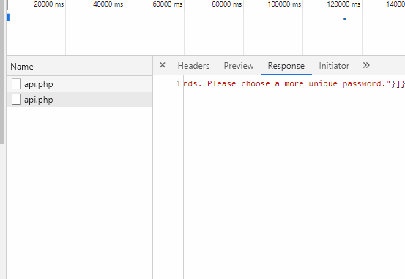

- Login registration using valid data

I interacted with the Login page and noticed the following :

- Request: GET, (an information was requested from the server), with status code 200 (action was successfully received) (action was successfully received)
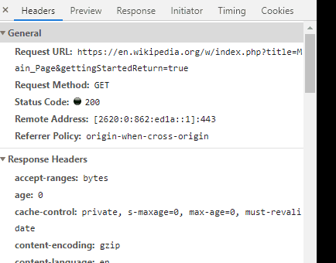

- Response is a html page.



- Cookies & Cache with more information

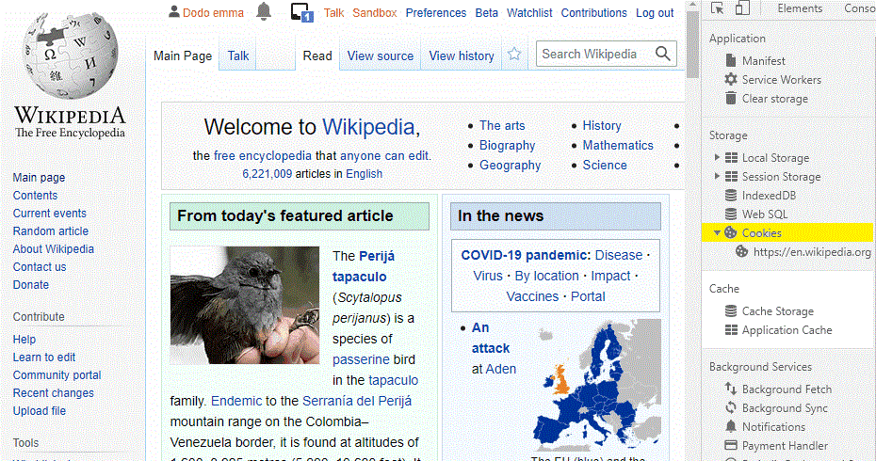

- Search Function:

- I called the "Search" function looking for information about "Unit Testing"

- Request: GET, (an information was requested from the server), with status code 200 (action was successfully received) (action was successfully received)

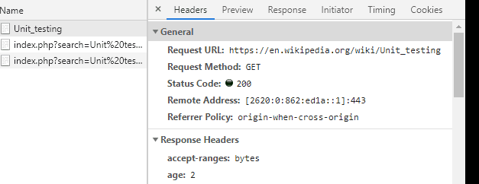


- The response is a html page.

- Cookies & Cache with more information

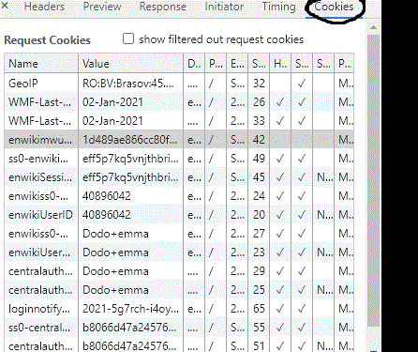

- Search Function:

- I called the "Search" function looking for information about "Unit Testing".
- Then Contents Description was called with the following observations :

- Request: GET, (an information was requested from the server), with status code 200 (action was successfully received) (action was successfully received)
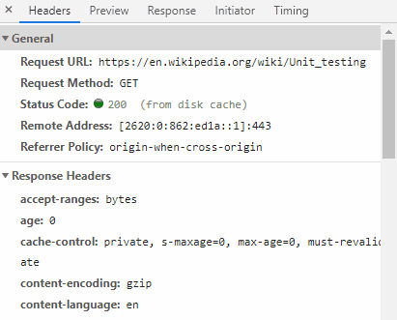

- The response is a html page.

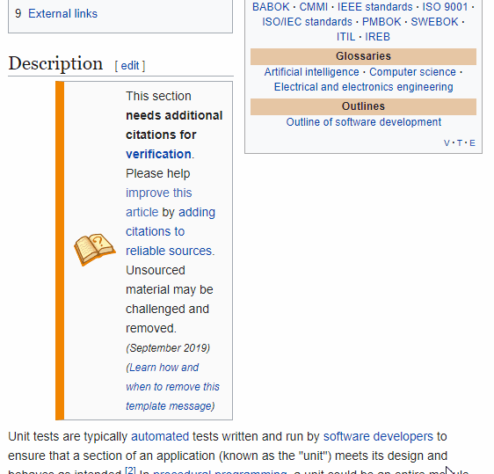

- Cookies & Cache with more information

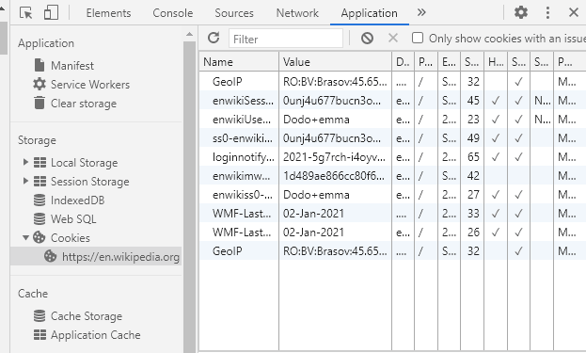

- Search Function:

- I opened the "Search" function looking information about "Film industry"
- Request: GET, 3 requests are being executed.
The first two are redirects(status 302) and the last one serves the content (status 200)
- Time (see pictures)
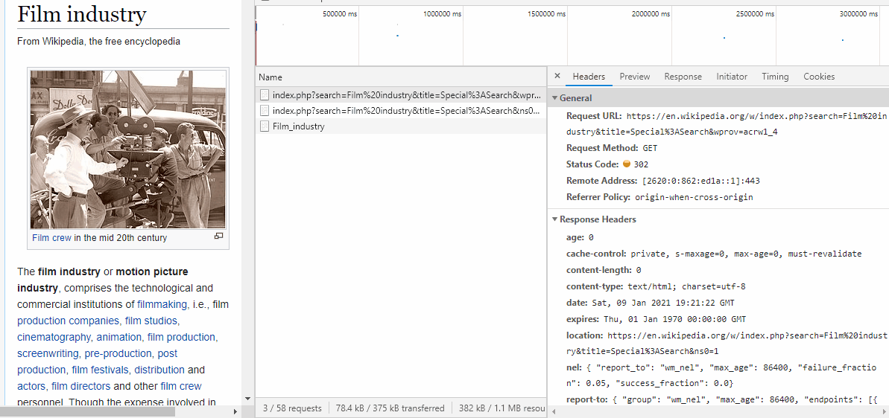

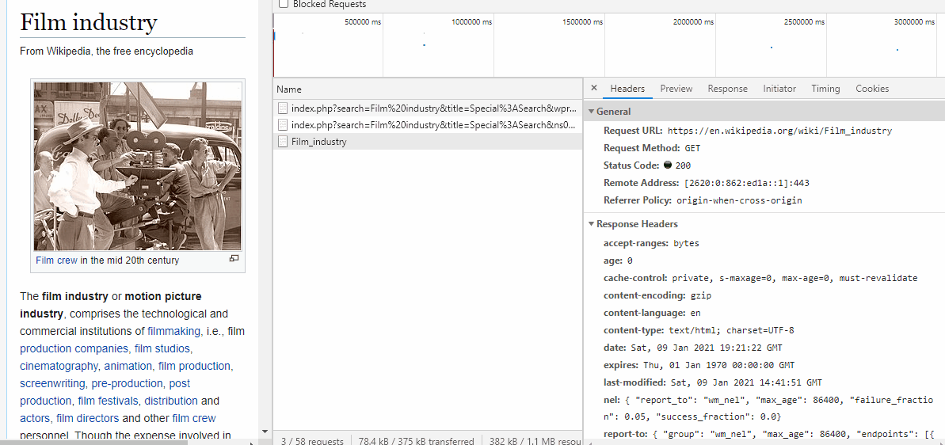

Time for each request:
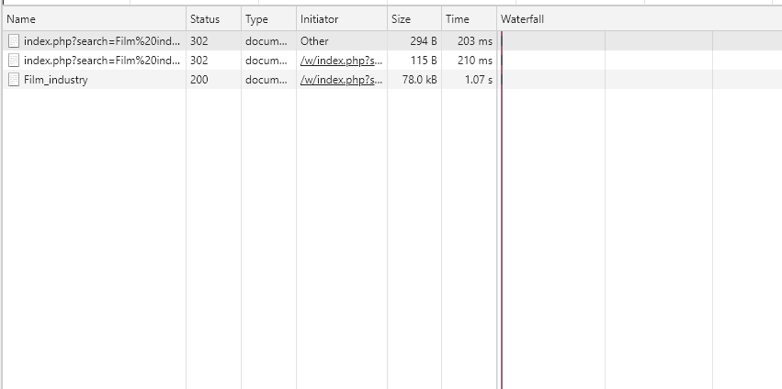

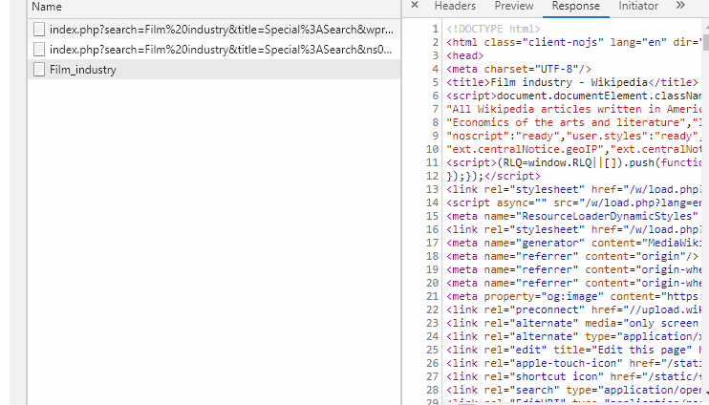
- The response is a html page.

- Cookies & Cache with more information

